Chapter 1

Investigating the role of pathogenesis in RNA virus spillover

**Introduction**

Interspecies pathogen transmission is a multifactorial process with both extrinsic drivers and intrinsic pathogen factors playing major roles in the process (Plowright et al. 2017). Whilst there has been much investigation of specific characteristics of pathogens involved in cross species transmission, there has been little research on the interplay between host and pathogent The potential role of infectious disease pathogenesis, defined as the manner in which a pathogen infects, reprocess, within a host and is transmitted between hostsin cross species transmission was first raised by Pulliam in 2009, but it has proven to be a difficult question to answer(Pulliam and Dushoff 2009).  The major factors influencing pathogenesis are likely cellular receptor used by the virus for attachment to host cells and the distribution of those receptors within different tissues and/or organs.The cellular-level mechanisms of pathogenesis are are known in well-studied viral systems such as influenza, however, much of that detailed knowledge is likely to be absent in many cases, therefore cell tropism and organ systems affected can serve as a proxy to study how infectious disease pathogensis is related to cross species transmission.Additionally, the method of within host spread of the pathogen may play an important role. Further to investigating the potential role of pathogenesis in cross species transmission there is the challenge of trying to incorporate this information into any predictive framework.

The initial “decision” for a virus upon contact with a new potential host is that of receptor selection. Making contact with a compatible receptor allows the virus to attach to and gain entry to the cell and consequently access the cellular machinery it requires for its replication cycle. Viruses that can infect multiple hosts tend to use an evolutionarily conserved receptor. A good example of this would be rabies virus, which uses the nACh-receptor which is very conserved across all mammals, and rabies has been shown to possess the ability to infect all eutherian mammals. (ref) Another option is to have multiple potential receptors that can be used. Foot-and-mouth disease virus has at least 3 potential integrin receptors along with Fc receptors it can use, giving it the ability to infect most known cloven-hoofed mammals (ref).

In addition to receptor selection, a large part of cellular pathogenesis and within-host infection dynamics are controlled by the distribution of the receptor used by the virus. The most studied system of receptor distribution is in different host species infected by influenza virus. . Avian and human influenza strains preferentially use differently terminated sialic acid receptors with SAα2,3Gal (avian receptor) and SAα2,6Gal (mammalian receptor) terminated saccharides distributed inin the upper respiratory tract of birds and humans, respectively. However, both types of receptor are also present in the upper respiratory tract of pigs giving rise to the pigs as a “mixing vessel” theory of flu recombination and evolution (Ma et al. 2008). As the pig upper respiratory tract expresses both of these receptors that allows for coinfection with an avian and human strain and recombination to produce a highly pathogenic strain that is more transmissible in people than an avian strain, such as was the case in the 2009 swine flu epidemic. Additionally, distribution of receptors in humans is of import. Humans possess SAα2,3Gal receptors, but only in their lower respiratory tract (de Graaf and Fouchier 2014). So while people do occasionally become infected with avian influenza, this subtle difference in receptor distribution plays a huge role, both in disease pathogenesis and in transmissibility of infection. The presence of the virus and subsequent replication in the lower respiratory tract results in a much more severe infection with higher morbidity and mortality than a typical human strain of flu. Additionally, the fact that the virus can not replicate in the upper respiartoiry tract, makes it difficult for the virus to be transmitted via respiratory aerosol.

Waterfowl are considered as the primary wild reservoir of avian influenza strains and their role in this again partly comes down to receptor distribution. The SAα2,3Gal receptors used by the influenza virus are present in large amounts in the intestinal tract of many species of migratory waterfowl (Costa et al. 2012). Waterfowl belonging to the *Anatidae* family (ducks, geese, and swans) are the primary reservoir of all 16 hemagglutinin and 9 neuraminidase subtypes of avian influenza viruses (Hansbro et al. 2010). Migration by these birds results in the inoculation of waterways with live influenza virus which is relatively stable in the water (Blagodatski et al. 2021). Additionally, there is also the potential for free-ranging domestic fowl to be exposed to faeces containing avian influenza from these birds.

With regards to within host spread of a virus and the potential role of this in spillover, Canine distemper virus is considered a multi-cell and multi-host pathogen that has the ability to infect three different types of host cells; epithelial, lymphoid, and neurological cells (Rendon-Marin et al. 2019).  CDV predominantly uses SLAM/CD150 as a receptor, which is expressed on activated T- and B- lymphocytes, and dendritic cells (DCs) and macrophages. During the first stages of infection within the host, resident DCs and alveolar macrophages in the respiratory tract are infected along with other cells which express CD150 in the alveolae. Infected cells carry the virus to the draining lymph node where resident activated T-cells and B-cells are infected through the CD150 receptor, resulting in virus amplification and the initiation of primary viremia. The virus gets disseminated to secondary lymphoid organs and subsequently a systemic spread through the entire immune system, thendisseminates to brain, liver, skin, gastrointestinal tract, genitals, and respiratory mucosal surfaces. This rapid systemic spread, particularly to respiratory mucosa results in the potential for rapid transmission dynamics through close contact populations. This pathology of using the lymphatic system to spread systemically almost is almost certainly involved in this virus’ ability to infect a wide range of species.

Here, we synthesize available literature on cross-species transmission events to determine how aspects of viral pathogenesis affect cross-species transmission in RNA viruses. First, weidentify how tissue tropism and the mechanism of within host spread influence cross species transmission. We then ,we assess the role cellular pathogenesis, including cell tropism, cellular receptor, plays in cross species transmission.We hypothesize that RNA virus tissue tropism,and those using broadly conserved receptors or those that can use alternate receptors will be more likely to transmit to alternate hosts.

**Tissue Tropisms of Avian Influenza A Viruses Affect Their Spillovers from Wild Birds to Pigs (Zhang et al. 2020)**

# Sialic Acid Receptors: The Key to Solving the Enigma of Zoonotic Virus Spillover

(Kuchipudi et al. 2021)

# Virulence mismatches in index hosts shape the outcomes of cross-species transmission

(Mollentze et al. 2020)

[Ecology, evolution and **spillover** of coronaviruses from bats.](https://pubmed.ncbi.nlm.nih.gov/34799704/)(Ruiz-Aravena et al. 2022)

**Methods**

**Data acquisition and overview**

A search of the Pub med database was performed as described below. These search results were then screened using the metagear package in R according to the Prisma guidelines ref fig. **write about what data was included from each paper.** Following this a secondary search was conducted to provide known pathological data for each virus **again list what pathological traits acquired.defined as zoonotic, anthroponotic, not zoonotic-defintio of these. “Not zoonotic” being defined as a virus which is not considered to infect humans. Within the the larger dataset of specfici host interactions, “anthroponotic” is defined as a virus which has been transmitted from a human reservoir to another species.**

**Repeated for distinct viruses. bias towards some of the major players I flu and rabies which hard multiple reports in different species.**

The resulting data were imported into R Studio (version 1.3.1056). A detailed description of data analysis is contained in the scripts within the project repository (https://github.com/JJWilson1991/......). All analyses were conducted in the R programming environment (version 3.5.3.). References to packages in this methods section indicate specific packages used within the R environment to perform analyses.

**literature search**

A literature search was performed of the Pubmed data base according to prisma guidelines ()ref. The search terms described in figure x were used with the results being screen for eligibility using the Metagear package in R**. Eligibility criteria desbed in fig x.**

|  |  |
| --- | --- |
| **Exclusion criteria** | **Inclusion criteria** |
| **Experimental Data**  **Review article**  **Irrelevant** | **Evidence of transmission from reservoir to spillover species. (in descending strength of support )**  **-molecular evidence (virus recovery, PCR etc)**  **-phylogentic**  **-serological**  **-epidemiological** |

Records identified from*:

Databases (n = 1) (NCBI)

Records removed *before screening*:

Duplicate records removed (n =0 )

Records removed for other reasons (n =0 )

Records screened

(n =7258)

Records excluded**

(n = 2976)

Reports sought for retrieval

(n =680 )

Reports not retrieved

(n =0 )

Reports assessed for eligibility

(n =680 )

Reports excluded:

Experiment (n =)

Irrelevant (n = )

Studies included in review

(n = 189)

**Identification of studies via databases and registers**

**Identification**

**Screening**

**Included**

Table X

Figure X

**Multiple correspondence Analysis**

To analyse the relationship between pathological parameters, multiple correspondence analysis (MCA) was conducted. MCA is a descriptive technique designed to measure correspondence between the rows and columns in tables of data. The object of MCA is to visualize the relationship of categorical variables. Correspondence analysis is used to explore the relationship between variables by comparison with distance in multiple dimension space. The first two dimensions can usually explain most of the variation seen in the data. Following data processing a total of n=213 rows along with 31 columns were uses for MCA. ThebMCA was also repeated with just the distinct viruses n=52, to remove bias in the correspondence caused by viruses which occur often in the literature in spillover events between multiple different species eg influenza. Multiple correspondence analysis was conducted on the data using the package *FactoMineR ref.*

**Results**

A total of 189 articles were enterered into the database and following processing, this resulted in n=213 unique entries of virus-reservoir host-spillover host interactions. This was comprised of n=52 distinct viruses. The unknown data for pathology-related variables are summarized in table x.

|  |  |
| --- | --- |
| Pathology variable | Unknown data |
| Cellular Receptor | 14/52 |
| Within host spread mechanism | 14/52 |
| Cell tropism | 5/52 |
| Organ systems affected | 3/52 |

The most frequent reservoir host was humans 34/213 followed by pigs and dogs (supplementary). Spillover hosts was dominated by humans with 103/213 recorded.

Table X

**Zoonotic Interactions**

The nature of interactions between reservoir hosts and spillover hosts is represented in figure X

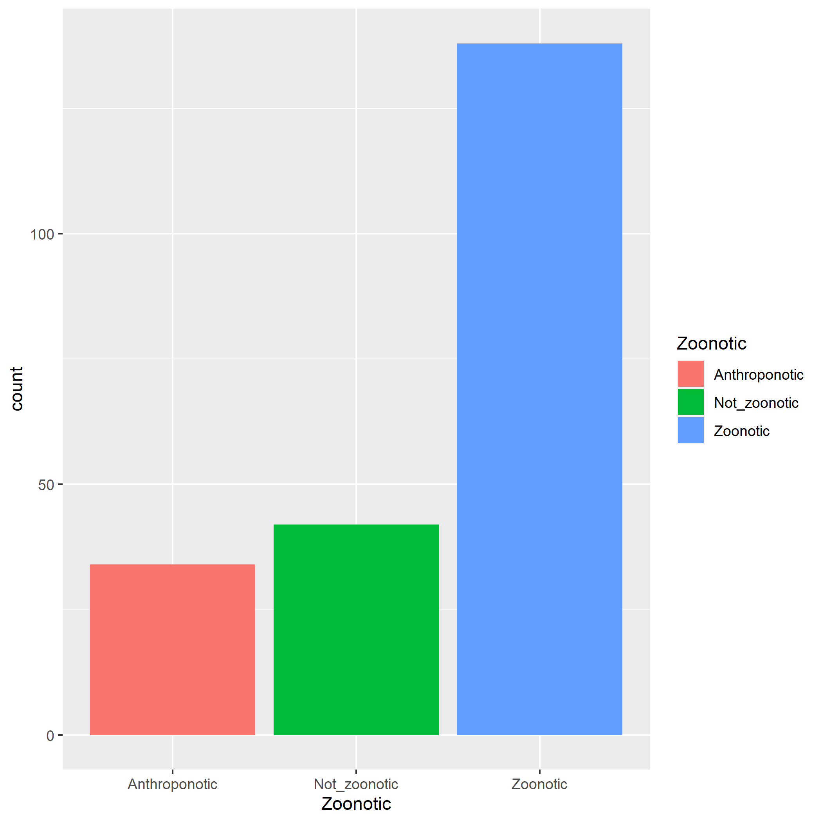

Fig X

**Pathological Data**

***The most common organ pathologies recorded are represented in figure x.***

***CT:macrophages>neurons > lymphomcytes>resp>***

**Muliple correspondence analysis**

The first two dimensions of the MCA explain 35% of the variance in the data. The major variables which contribute to the first two dimensions are shown in figure x.

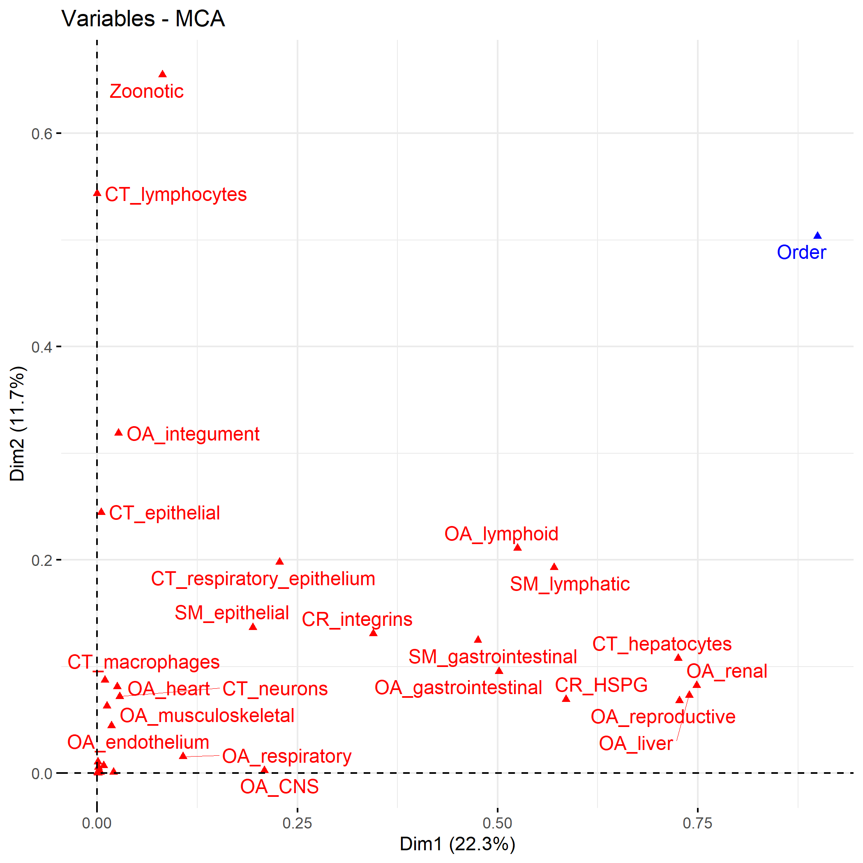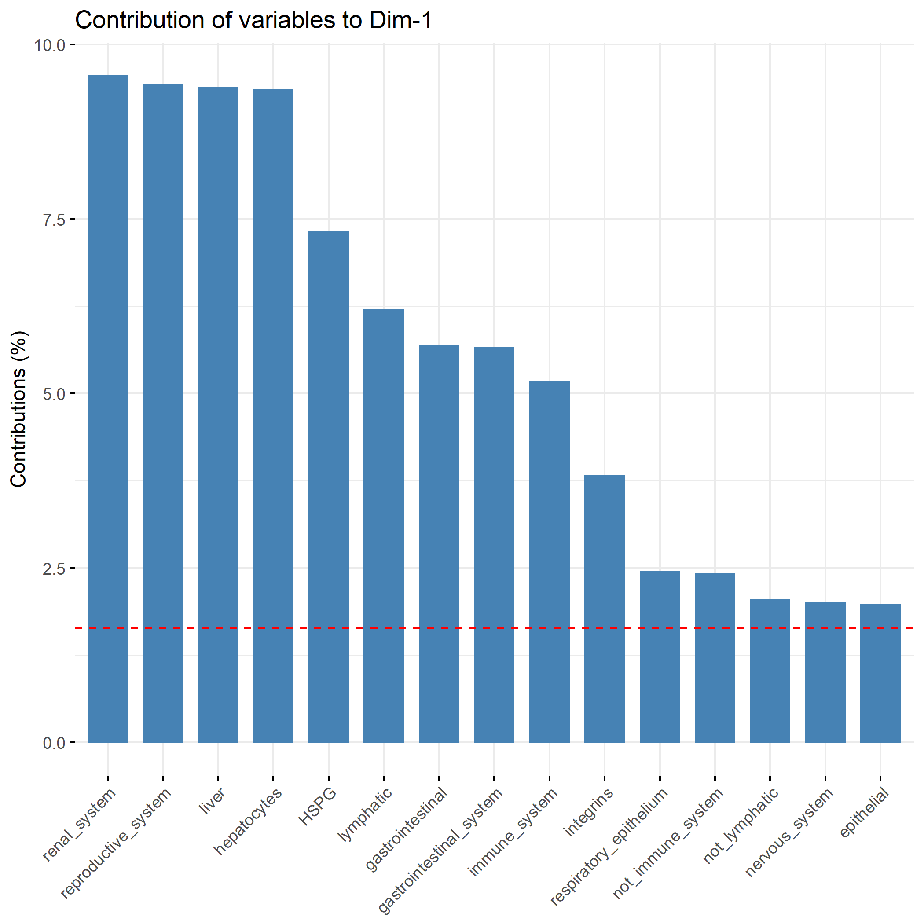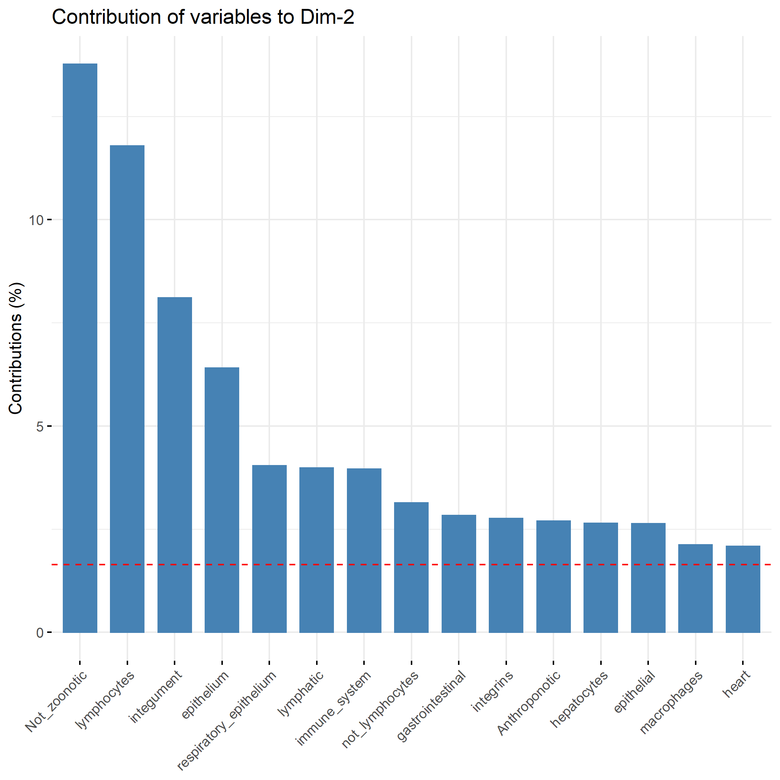

Figure X

The MCA for individual host interactions (figure X) clusters epithelial spread and respirartory pathology with anthroponosis, suggesting an association between these variables. There also appears to be an assoiaction between lymphocytic tropism and not being zoonotic.

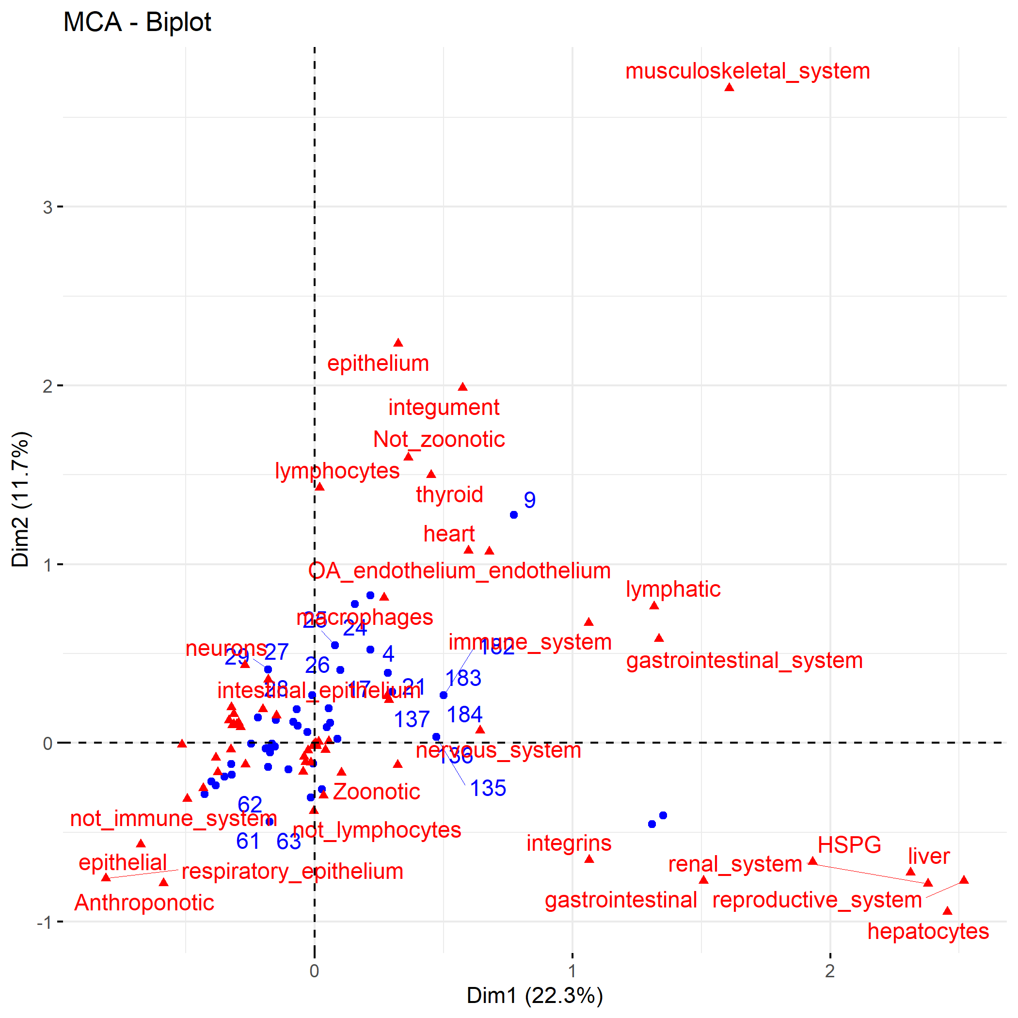

[Grab your reader’s attention with a great quote from the document or use this space to emphasize a key point. To place this text box anywhere on the page, just drag it.]

When the MCA is repeated with just distinct viruses (fig X) Gastrointestinal pathology is associated with notsoonotic in addition to lymphocyte tropism.

Fig X

95% confidence ellipses for zoonotic and anthropontic cluster separately from not_zoontoic , suggest pathological features differ. Anthroponotic appears to be a distinct subset with the larger zoonotic ellipsis (fig X).

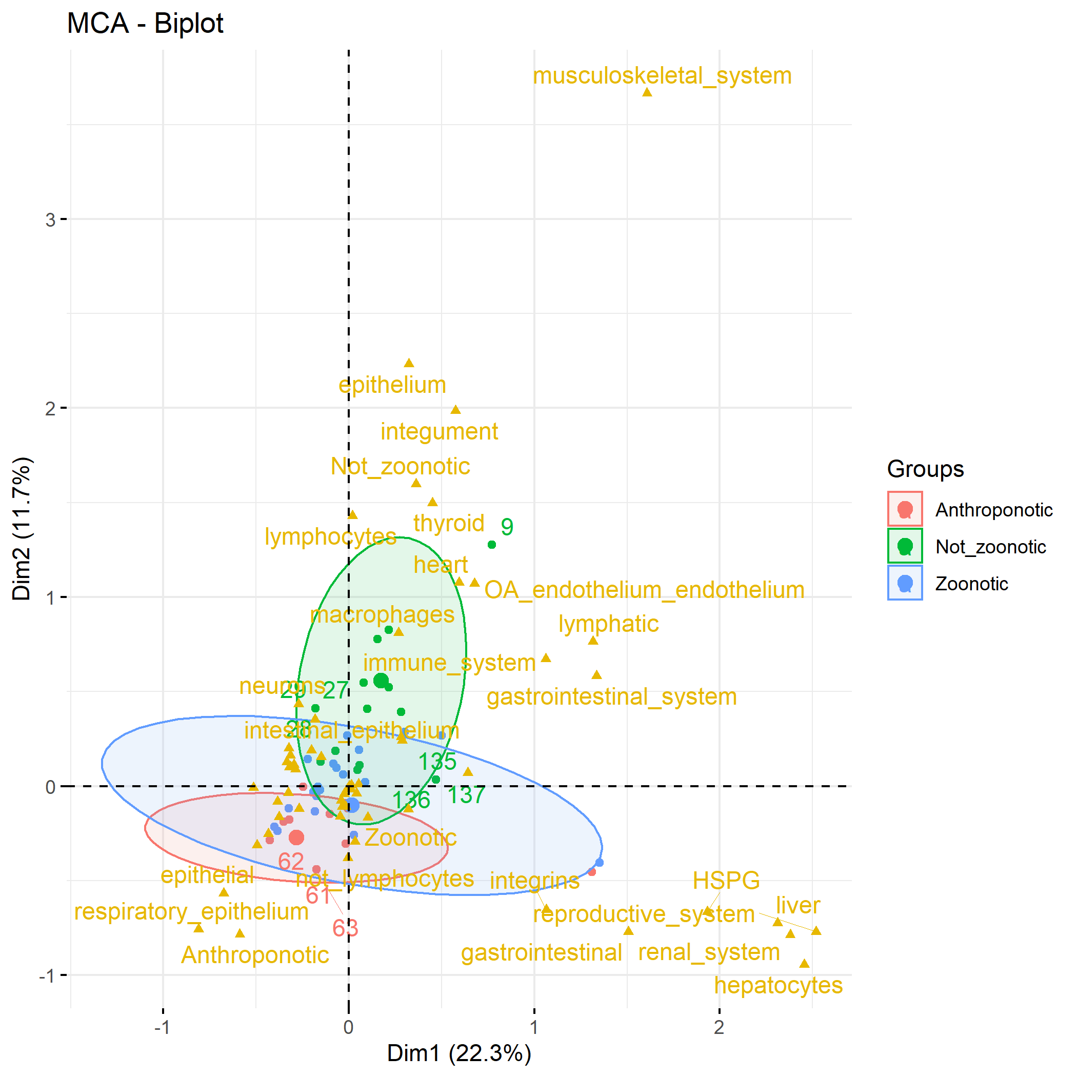

Fig X

The zoonotic ellipses for the disnct virus MCA have the zoonotic ellipse as a smaller elipse within a larger ellipse for not-zoonotic.(fir X)

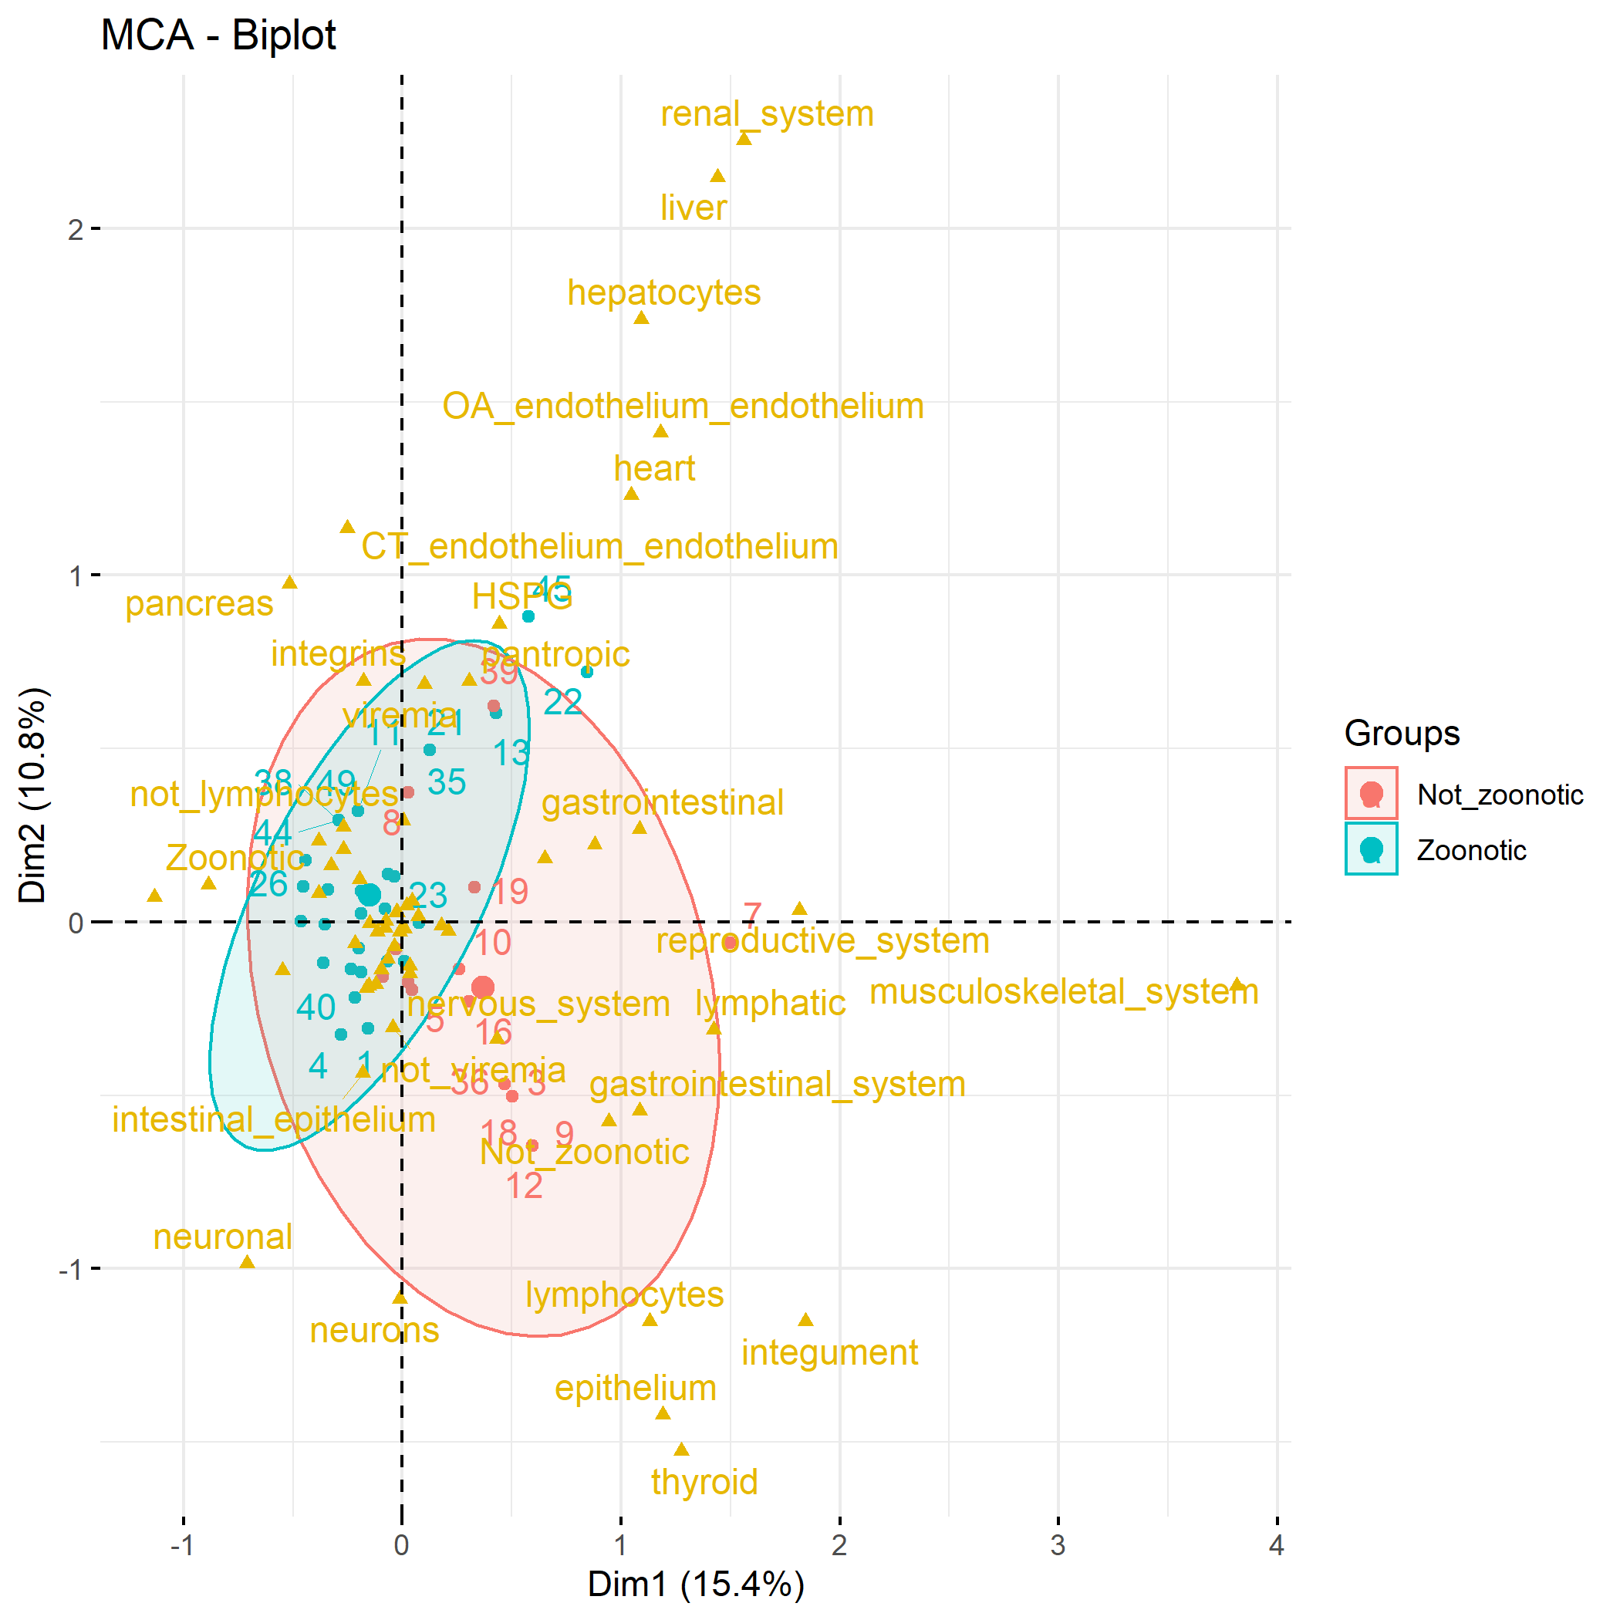

Fig X

**Discussion**

The current study analysed the results of a literature search for cross-species transmission events in RNA viruses and looked for trends in the pathological features associated with theses infections.

**Species bias**

64% of articles involved humans as either reservoir or spillover host highlighting the inherit human bias in cross species transmission research. Humans are in close proximity to spillover events involving them as reservoir or spillover hosts and can report symptoms etc, They also have a vested intest in research involving these diseases that affect them directly. This is reflected in the 4 most common viruses in the dataset; influenza A, rabies, hepatitis E and simian foamy virus which are all known to infect humans. In addition to cases involving humans themselves 66% of records involved what would be considered a domestic species (either livestock or pet) as reservoir or spillover host, with only 8% of records involving neither humans nor domestic species. This demonstrates the inherent bias that exists in this type of data with either the proximity to these species resulting in reporting biases or the interest in surveillance of diseases in theses species.

**Primate bias**

In addition to domesticated species whereby contact is likely an important facto the other major group of species with which humans exchanged viruses are primates. This is likely due to lower barriers to cross species transmission in this case due to phylogenetic relatedness (ref)

**anthroponosis**

The association between anthroponosis, those cases of virus transmission from human to other species and respiratory pathology may have to do with human behaviours. Respiratory pathology is generally caused by viruses with a respiratory droplet mode of transmission. Other methods of trnasmisoon less likely from humans due to human behaviours related to hygiene reducing the risk of faeco-oral transmitted pathogens and those transmitted by direct contact. (is there a reference for this) This was reflected in htneMCA where zoonosis and anthroposis formed a subset within a larger more varible group containing cross species events not involiving humans. This may also reflect a narrower range of pathologies. The occurrence of the antropontoic ellipsis as a smaller ellipsis as a smaller ellipsis with the zoonotic ellipsis in the MCA for the individual host MCA and the zoonotic ellipsis asa smaller ellipsis asa smaller ellipsis with a larger not zoonotic in the disntinct virus MCA seems to reflect this. This raises an interesting question if this will become less common due to increased “respiratory hygiene” as a result of the COVID-19 pandemic.

Not_zoonotic ie animla to animla in this study may be associated with gastrointestinal-human behavious reducing risk of gastrointestinally transmitted viruses compared to animals

**repiratory**

With the exception og influenza, respiratory tropic viruses tended to be transmitted between more closely related species. Does high barriers to infection due to mucosal immunity require more conserved receprtors ie between more related species. ??

***Receptor difficulties***

*The percentage of unknowns for pathological data increased the more micorscpopic the level of the pathologivcal variable with cellular receptors being the most unknown. While m*any of the cellular receptors for viral entry in the host are unknown, equally many of the recorded receptors are putative or just one piece of thecellular attachement and entry puzzle making this difficult to analyse. Although some basic types of receptors did occur regularly in integrins and HSPGS. The current absence of high quality data in this area makes this area difficult to further analyse and calls for more collaboration and focused efforts amongst the scientific community to identify receptors which may be indicative of spillover risk.

Punitive receptors, unknown receptros, unillucidated mechanisms-> difficult to make inferences based on recpetros. HSPGS and integrins did seem to appear regularly (read and ref about conservation of these)

**Neural conservation**

Neuronal and non-neuronal cluster differently. Those with primary neuronal tropism have known broad host range. **Can we talk about conservation of neral receptors etc here.(Le Novere and Changeux 1995, Gotti and Clementi 2004) neuronal conserved receptors and immunologically preserved Do other organ systems have conserved receptors?**

**endothelium**

Despite being associated with cross species transmsisions events causing severe illness, such as haemorrhagic fever viruses, endotheliotropic viruses there were not a large number of records with endothelial pathology and there wasn’t a strong correspondacne with anything. This may be due to the difficulty in accessing this recpeotrs .

**lymphoid tropism and greater range of species ie not_zoontoic**

**viruses that were not zoonotic had a greater range of pathologies. Lymphoid tropism was associated with viruses categorized as not_zoontoic. This greater host range may be related to soopting the host immune system to bypass some of these interspecific barriers or perhaps there maybe conserved immunological virus receptors between species..**

**lymphoid-Is there conservation of receptor here or does this mechanism allow a shortcut? Coopts the immune system**

**Viremia and hspg may be assoicated**

***LIMITATIONS***

no background, bias towards virus/host interactions of human and/or economic importance, lack of pathogenesis data

*some outliers eg. muscle, thyroid caused by individual recordings.*

**#9 and musculoskeletal comes for BVD- well studied, unique case of viral pathogenesis.**

**Conclusions**

*Some of the tredns shown here reflect some previously demonstrated trends ie Close-together and closely related (ref). but addicitionally there are trends involving pathological data and*

**Trends exist**

**Data on some of the molecular pathogneeis could improve.**

BLAGODATSKI, A., K. TRUTNEVA, O. GLAZOVA, O. MITYAEVA, L. SHEVKOVA, E. KEGELES, N. ONYANOV, K. FEDE, A. MAZNINA, E. KHAVINA, S. J. YEO, H. PARK, ANDP. VOLCHKOV. 2021. Avian Influenza in Wild Birds and Poultry: Dissemination Pathways, Monitoring Methods, and Virus Ecology. Pathogens 10.

COSTA, T., A. J. CHAVES, R. VALLE, A. DARJI, D. VAN RIEL, T. KUIKEN, N. MAJO, ANDA. RAMIS. 2012. Distribution patterns of influenza virus receptors and viral attachment patterns in the respiratory and intestinal tracts of seven avian species. Vet Res 43: 28.

DE GRAAF, M., ANDR. A. FOUCHIER. 2014. Role of receptor binding specificity in influenza A virus transmission and pathogenesis. EMBO J 33: 823-841.

GOTTI, C., ANDF. CLEMENTI. 2004. Neuronal nicotinic receptors: from structure to pathology. Prog Neurobiol 74: 363-396.

HANSBRO, P. M., S. WARNER, J. P. TRACEY, K. E. ARZEY, P. SELLECK, K. O'RILEY, E. L. BECKETT, C. BUNN, P. D. KIRKLAND, D. VIJAYKRISHNA, B. OLSEN, ANDA. C. HURT. 2010. Surveillance and analysis of avian influenza viruses, Australia. Emerg Infect Dis 16: 1896-1904.

KUCHIPUDI, S. V., R. K. NELLI, A. GONTU, R. SATYAKUMAR, M. SURENDRAN NAIR, ANDM. SUBBIAH. 2021. Sialic Acid Receptors: The Key to Solving the Enigma of Zoonotic Virus Spillover. Viruses 13.

LE NOVERE, N., ANDJ. P. CHANGEUX. 1995. Molecular evolution of the nicotinic acetylcholine receptor: an example of multigene family in excitable cells. J Mol Evol 40: 155-172.

MA, W., R. E. KAHN, ANDJ. A. RICHT. 2008. The pig as a mixing vessel for influenza viruses: Human and veterinary implications. J Mol Genet Med 3: 158-166.

MOLLENTZE, N., D. G. STREICKER, P. R. MURCIA, K. HAMPSON, ANDR. BIEK. 2020. Virulence mismatches in index hosts shape the outcomes of cross-species transmission. Proc Natl Acad Sci U S A 117: 28859-28866.

PLOWRIGHT, R. K., C. R. PARRISH, H. MCCALLUM, P. J. HUDSON, A. I. KO, A. L. GRAHAM, ANDJ. O. LLOYD-SMITH. 2017. Pathways to zoonotic spillover. Nat Rev Microbiol 15: 502-510.

PULLIAM, J. R., ANDJ. DUSHOFF. 2009. Ability to replicate in the cytoplasm predicts zoonotic transmission of livestock viruses. J Infect Dis 199: 565-568.

RENDON-MARIN, S., R. DA FONTOURA BUDASZEWSKI, C. W. CANAL, ANDJ. RUIZ-SAENZ. 2019. Tropism and molecular pathogenesis of canine distemper virus. Virol J 16: 30.

RUIZ-ARAVENA, M., C. MCKEE, A. GAMBLE, T. LUNN, A. MORRIS, C. E. SNEDDEN, C. K. YINDA, J. R. PORT, D. W. BUCHHOLZ, Y. Y. YEO, C. FAUST, E. JAX, L. DEE, D. N. JONES, M. K. KESSLER, C. FALVO, D. CROWLEY, N. BHARTI, C. E. BROOK, H. C. AGUILAR, A. J. PEEL, O. RESTIF, T. SCHOUNTZ, C. R. PARRISH, E. S. GURLEY, J. O. LLOYD-SMITH, P. J. HUDSON, V. J. MUNSTER, ANDR. K. PLOWRIGHT. 2022. Ecology, evolution and spillover of coronaviruses from bats. Nat Rev Microbiol 20: 299-314.

ZHANG, X., F. L. CUNNINGHAM, L. LI, K. HANSON-DORR, L. LIU, K. WATERS, M. GUAN, A. K. OLIVIER, B. S. SCHMIT, J. M. NOLTING, A. S. BOWMAN, M. K. TORCHETTI, T. J. DELIBERTO, ANDX. F. WAN. 2020. Tissue Tropisms of Avian Influenza A Viruses Affect Their Spillovers from Wild Birds to Pigs. J Virol 94.